Oop lab 8
24k-0661
Q1
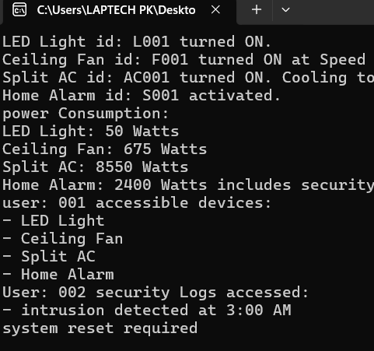
#include <iostream>
#include <string>
#include <vector>
using namespace std;

class User;

class Device {
protected:
string deviceID;
string deviceType;
double powerRating;
bool status;

public:
Device(string id, string type, double power) : deviceID(id), deviceType(type), powerRating(power), status(false) {}
virtual void turnOn() { status = true; }
virtual void turnOff() { status = false; }
virtual double calculatePowerUsage(int hours) = 0;
string getDeviceType() const { return deviceType; }
bool isOn() const { return status; }
string getID() const { return deviceID; }
};

class Light : public Device {
public:
Light(string id, string type, double power) : Device(id, type, power) {}
void turnOn() override {
status = true;
cout << deviceType << " id: " << deviceID << " turned ON." << endl;
}
void turnOff() override {
status = false;
cout << deviceType << " id: " << deviceID << " turned OFF." << endl;
}
double calculatePowerUsage(int hours) override {
return powerRating * hours;
}
};

class Fan : public Device {
int speed;
public:
Fan(string id, string type, double power, int spd) : Device(id, type, power), speed(spd) {}
void turnOn() override {
status = true;
cout << deviceType << " id: " << deviceID << " turned ON at Speed " << speed << "." << endl;
}
void turnOff() override {
status = false;
cout << deviceType << " id: " << deviceID << " turned OFF." << endl;
}
double calculatePowerUsage(int hours) override {
return powerRating * hours * speed;
}
};

class AirConditioner : public Device {
double desiredTemp;
double currentTemp;
public:
AirConditioner(string id, string type, double power, double temp) : Device(id, type, power), desiredTemp(temp), currentTemp(30) {}
void turnOn() override {
status = true;
cout << deviceType << " id: " << deviceID << " turned ON. Cooling to " << desiredTemp << "°C." << endl;
}
void turnOff() override {
status = false;
cout << deviceType << " id: " << deviceID << " turned OFF." << endl;
}
double calculatePowerUsage(int hours) override {
return powerRating * hours * (1 - (currentTemp - desiredTemp) / 100);
}
};

class SecuritySystem : public Device {
string lastIntrusion;
friend class User;
friend class MaintenanceTool;
public:
SecuritySystem(string id, string type, double power) : Device(id, type, power), lastIntrusion("intrusion detected at 3:00 AM") {}
void turnOn() override {
status = true;
cout << deviceType << " id: " << deviceID << " activated." << endl;
}
void turnOff() override {
status = false;
cout << deviceType << " id: " << deviceID << " deactivated." << endl;
}
double calculatePowerUsage(int hours) override {
return powerRating * hours;
}
};

class MaintenanceTool {
public:
void resetSecurity(SecuritySystem &sec) {
cout << "Security alerts for " << sec.deviceType << " id: " << sec.deviceID << " reset." << endl;
sec.lastIntrusion = "No intrusion detected";
}
};

class User {
string userID;
string role;
int accessLevel;
public:
User(string id, string r, int level) : userID(id), role(r), accessLevel(level) {}
void viewAccessibleDevices(const vector<Device*> &devices) {
cout << "user: " << userID << " accessible devices:" << endl;
for (auto d : devices) {
if (d->getDeviceType() != "security system")
cout << "- " << d->getDeviceType() << endl;
}
}
void accessSecurityLogs(SecuritySystem &sec) {
if (accessLevel >= 2) {
cout << "User: " << userID << " security Logs accessed:" << endl;
cout << "- " << sec.lastIntrusion << endl;
cout << "system reset required" << endl;
} else {
cout << "access denied for " << userID << "." << endl;
}
}
};

int main() {
User user1("001", "muskan", 1);
User user2("002", "Maintenance Staff", 2);

Light light1("L001", "LED Light", 10);
Fan fan1("F001", "Ceiling Fan", 75, 3);
AirConditioner ac1("AC001", "Split AC", 1500, 25);
SecuritySystem secSys1("S001", "Home Alarm", 100);

vector<Device*> devices = { &light1, &fan1, &ac1, &secSys1 };

light1.turnOn();
fan1.turnOn();
ac1.turnOn();
secSys1.turnOn();

cout << "power Consumption:" << endl;
cout << light1.getDeviceType() << ": " << light1.calculatePowerUsage(5) << " Watts" << endl;
cout << fan1.getDeviceType() << ": " << fan1.calculatePowerUsage(3) << " Watts" << endl;
cout << ac1.getDeviceType() << ": " << ac1.calculatePowerUsage(6) << " Watts" << endl;
cout << secSys1.getDeviceType() << ": " << secSys1.calculatePowerUsage(24) << " Watts includes security checks" << endl;

user1.viewAccessibleDevices(devices);
user2.accessSecurityLogs(secSys1);

return 0;
}
Q2
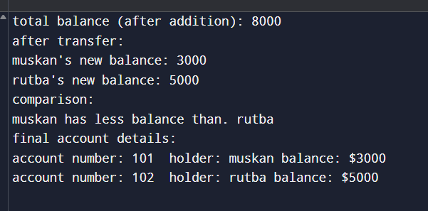
#include <iostream>
#include <string>
using namespace std;

class Account {
private:
string accNumber;
string accHolder;
double balance;

public:
Account(string accNo = "", string holder = "", double bal = 0.0) {
accNumber = accNo;
accHolder = holder;
balance = bal;
}

Account operator+(const Account &other) const {
Account temp;
temp.balance = this->balance + other.balance;
return temp;
}

Account &operator-=(double amount) {
if (amount > balance) {
cout << "insufficient funds in account of " << accHolder << "!" << endl;
} else {
balance -= amount;
}
return *this;
}

bool operator>(const Account &other) const {
return this->balance > other.balance;
}

void deposit(double amount) {
balance += amount;
}

friend ostream &operator<<(ostream &out, const Account &acc);

double getBalance() const {
return balance;
}

string getHolder() const {
return accHolder;
}
};

ostream &operator<<(ostream &out, const Account &acc) {
out << "account number: " << acc.accNumber
<< " holder: " << acc.accHolder
<< " balance: $" << acc.balance;
return out;
}

int main() {
Account acc1("101", "muskan", 5000);
Account acc2("102", "rutba", 3000);

Account total = acc1 + acc2;
cout << "total balance (after addition): " << total.getBalance() << endl;

acc1 -= 2000;
acc2.deposit(2000);
cout << "after transfer:" << endl;
cout << acc1.getHolder() << "'s new balance: " << acc1.getBalance() << endl;
cout << acc2.getHolder() << "'s new balance: " << acc2.getBalance() << endl;
cout << "comparison:" << endl;
if (acc1 > acc2)
cout << acc1.getHolder() << " has more balance than. " << acc2.getHolder() << endl;
else
cout << acc1.getHolder() << " has less balance than. " << acc2.getHolder() << endl;
cout << "final account details:" << endl;
cout << acc1 << endl;
cout << acc2 << endl;
return 0;
}
Q3
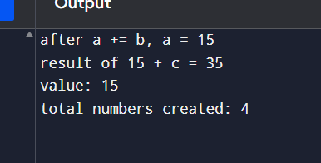
#include <iostream>
using namespace std;

class Number {
private:
int value;
static int count;

public:
Number(int v = 0) : value(v) { count++; }

Number& operator+=(const Number &other) {
value += other.value;
return *this;
}

friend Number operator+(int lhs, const Number &rhs);
friend void showValue(const Number &n);
friend void showCount();

int getValue() const { return value; }
};

int Number::count = 0;

Number operator+(int lhs, const Number &rhs) {
return Number(lhs + rhs.value);
}

void showValue(const Number &n) {
cout << "value: " << n.value << endl;
}

void showCount() {
cout << "total numbers created: " << Number::count << endl;
}

int main() {
Number a(10), b(5);
a += b;
cout << "after a += b, a = " << a.getValue() << endl;

Number c(20);
Number result = 15 + c;
cout << "result of 15 + c = " << result.getValue() << endl;

showValue(a);
showCount();

return 0;
}

